

**Batch: A1 Roll No.: 16010121045**

**Experiment / Assignment / Tutorial No:**

|  |
| --- |
| **TITLE:** To explore how contemporary principles of visual perception can be applied to UI/UX design |

**Objective:** To explore how contemporary principles of visual perception can be applied to UI/UX design, focusing on perceptual grouping and figure-ground organization from the perspective of Gestalt psychology.

______________________________________________________________________

**Expected OUTCOME of Experiment:**

**CO 4: Summarize the applications of UX design.**

**______________________________________________________________________**

**Books/ Journals/ Websites referred:**

[**https://pmc.ncbi.nlm.nih.gov/articles/PMC3482144/**](https://pmc.ncbi.nlm.nih.gov/articles/PMC3482144/)

**______________________________________________________________________**

**New Concepts to be learned:**

Gestalt Principals

**Background Theory:**

Gestalt principles of visual perception, such as proximity, similarity, continuity, and figure-ground organization, are fundamental in determining how users interpret and interact with visual content in digital interfaces. These principles help designers create intuitive interfaces by guiding users’ focus and enhancing user experience (UX). The concept of perceptual grouping allows the human brain to interpret complex environments efficiently, making it essential in UI/UX design, particularly for applications that deal with financial data, where clarity and organization are paramount.

**Introduction:**

This experiment explores the application of Gestalt principles to the HDFC Bank mobile app’s UI/UX. The design is critically evaluated based on how effectively it aligns with contemporary theories of visual perception. The goal is to enhance user experience by optimizing the layout of key elements such as payments, UPI transactions, profile management, and quick actions, ensuring that users can navigate the app with ease.

**Principles:**

* **Proximity:** Elements such as recent transactions and account information are grouped closely together, encouraging the user to perceive them as related. This simplifies navigation and reduces cognitive load.
* **Similarity:** Icons and buttons share the same color scheme and shape, helping users quickly identify actions. For example, similar icons for “Payments” and “UPI” allow for quicker decision-making.
* **Continuity:** The layout encourages a flow of actions, from login to transaction completion, without interrupting the user’s cognitive processing. For example, the flow from the home screen to payment details maintains continuity in user interaction.
* **Figure-Ground Organization:** The contrast between the background and the interactive elements ensures that key information such as payment options and account details stand out, enhancing focus and usability.

**Implementation of Gestalt Principles in Modern Apps:**

Modern applications across various domains have embraced Gestalt principles to create intuitive, user-friendly interfaces. These principles help to organize visual elements in a way that aligns with human cognitive processing, enabling users to navigate complex tasks with ease. Below are examples of how Gestalt principles are effectively implemented in modern apps:

**Proximity in Social Media Apps (Instagram):**

Instagram effectively uses proximity by grouping related functions like the “like,” “comment,” and “share” buttons under each post. This allows users to instinctively understand that these actions pertain to the post immediately above them. Similarly, stories from different users are spaced close together at the top of the screen, making it clear they belong to the same interactive feature.

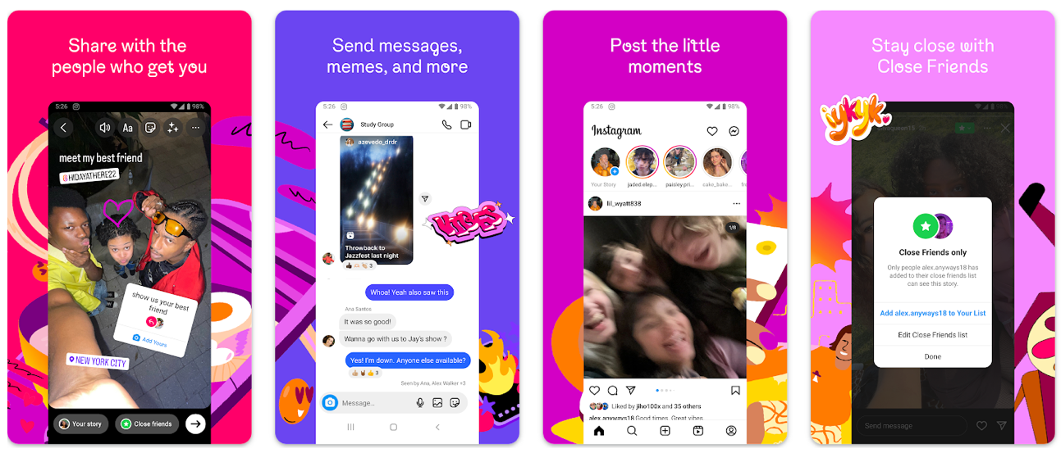

**Similarity in E-Commerce Apps (Amazon):**

On Amazon’s product pages, items such as “Add to Cart” and “Buy Now” buttons are styled similarly with consistent colors and shapes. This helps users immediately recognize these as primary actions. Additionally, Amazon uses similarity in its “Related Products” section, grouping items that have similar visual elements such as product images, prices, and ratings, guiding the user toward similar buying options.

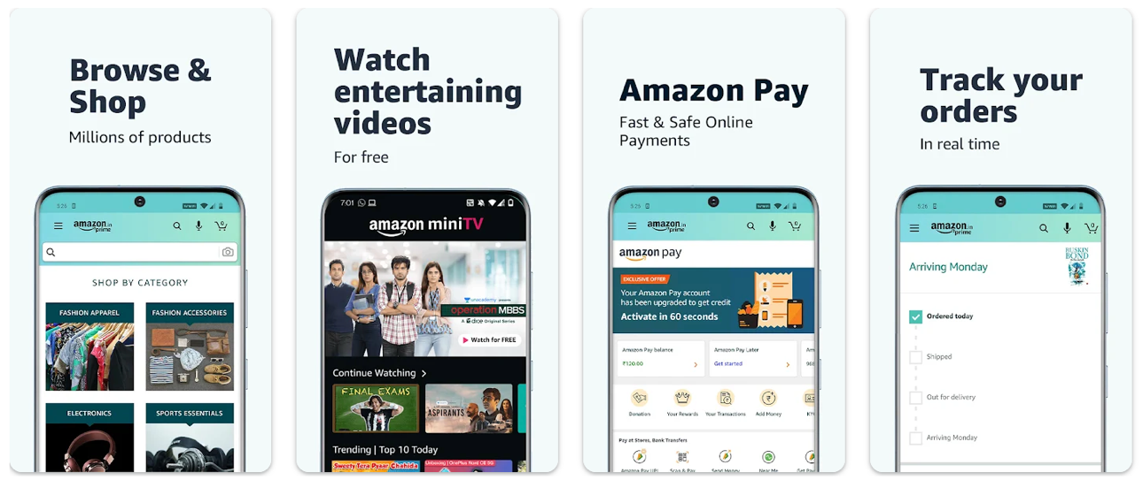

**Continuity in Navigation Apps (Google Maps):**

Google Maps implements continuity by using smooth, uninterrupted lines to represent roads and routes. These lines guide the user’s eye along the path, reducing the need for constant cognitive processing. The app also maintains a consistent flow from inputting directions to displaying the route, ensuring users can follow a clear process without confusion or abrupt changes in the interface.



**Figure-Ground in Music Streaming Apps (Spotify):**

Spotify’s use of figure-ground helps distinguish primary content (such as song titles and play buttons) from background elements. The dark background contrasts with lighter elements like text and album art, ensuring that users’ attention is focused on key interactive components. This principle is also applied in album or playlist views, where the artwork and track titles stand out against the darker interface.

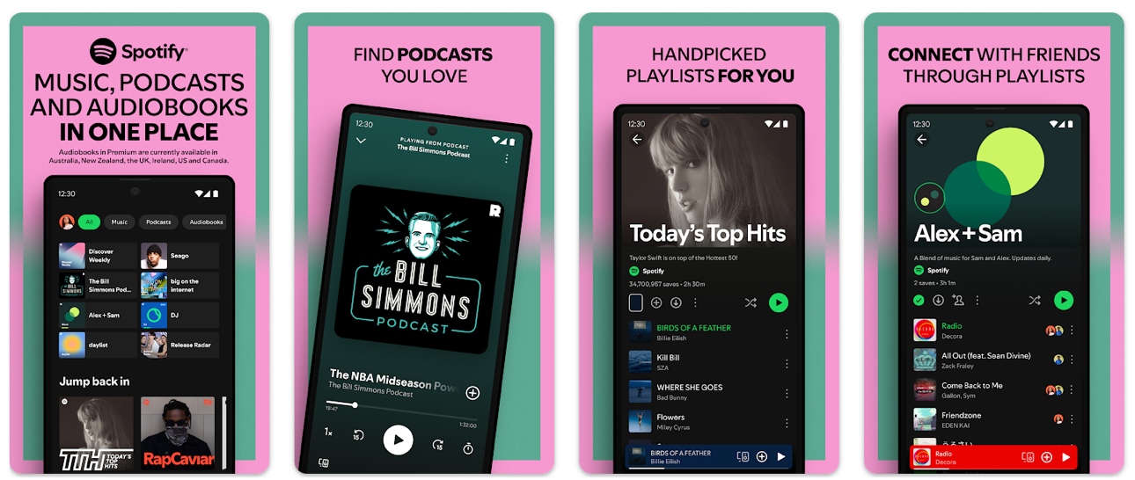

**Closure in Design Tools (Figma):**

Figma uses closure in its design elements to imply the completion of shapes and objects even when parts of the shape are missing. For example, when creating design frames or UI elements, Figma automatically highlights bounding areas, allowing users to perceive these as complete forms even if only a portion is visible on the canvas. This helps users maintain spatial awareness in a complex design environment.

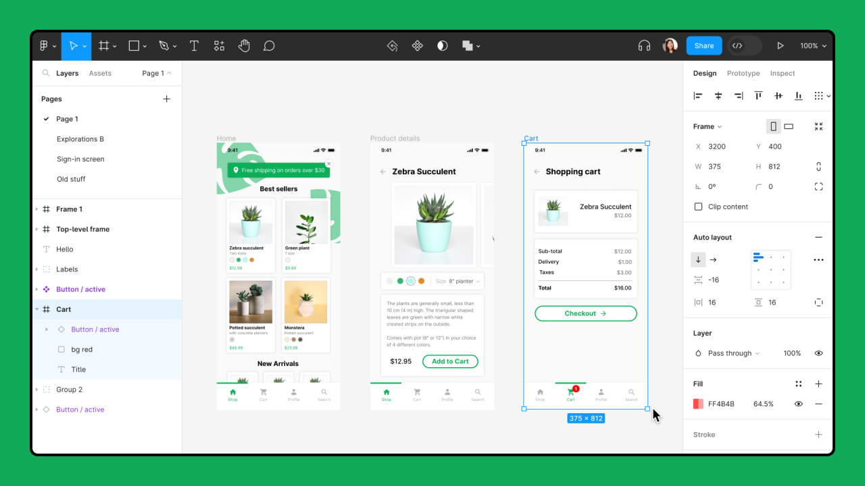

**Components:**

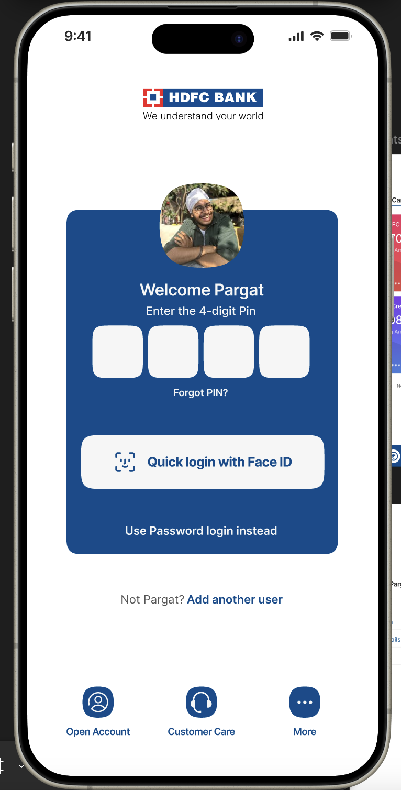

* **Login Screen:** Follows Gestalt’s principle of simplicity by focusing on a clean, minimalistic design, allowing users to quickly access key features like Face ID and password input.

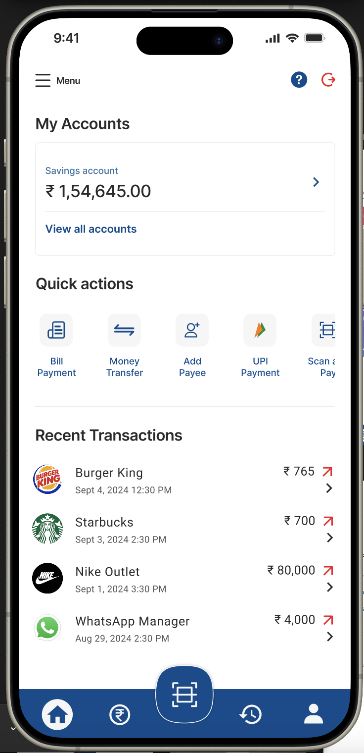

* **Home Page:** Organizes recent transactions, account details, and quick actions using proximity and similarity. Elements are visually grouped for intuitive navigation.

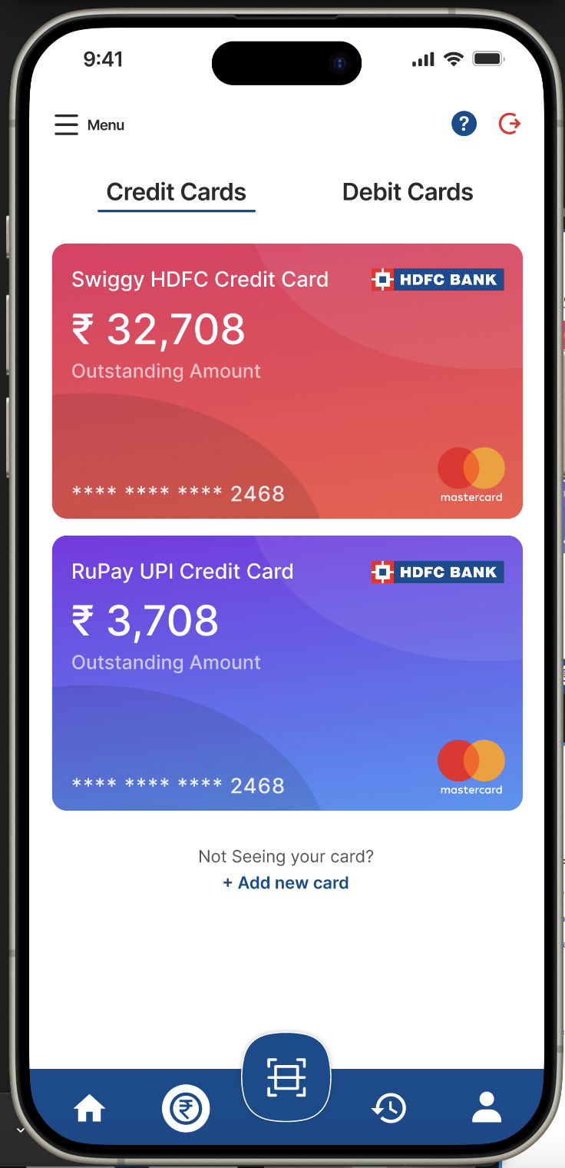

* **Payments Page:** Leverages color contrast and clear borders to distinguish between different types of cards and accounts. Continuity and closure help maintain visual order.

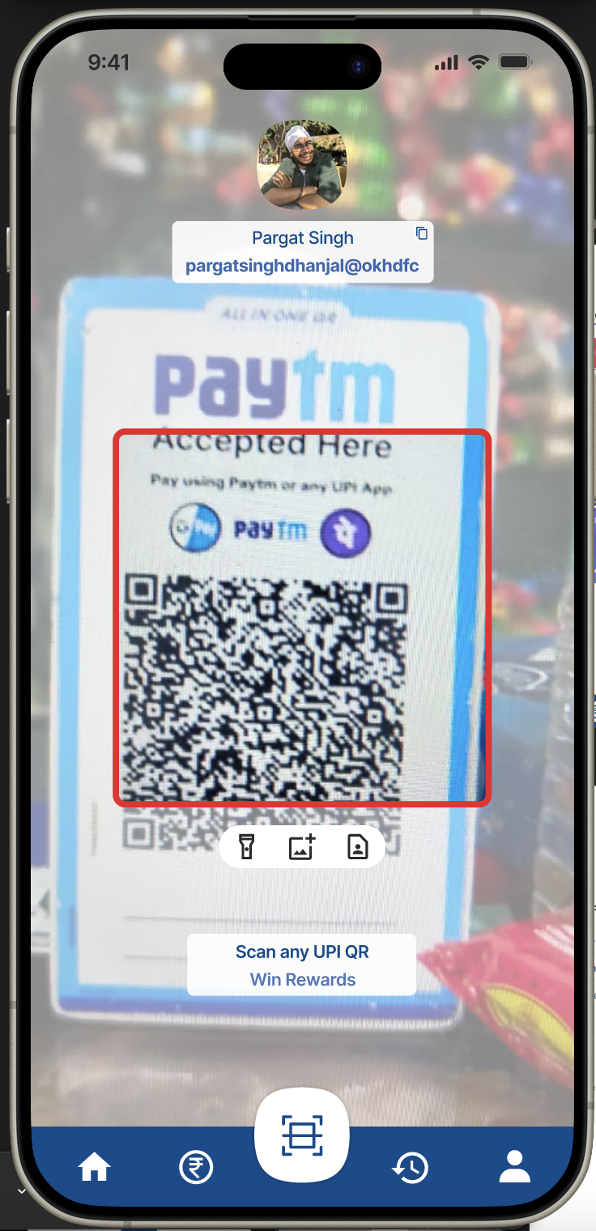

* **UPI Section:** Provides a QR code for easy scanning, highlighting the focus of action. The clear organization of elements around the user’s profile ensures smooth navigation.

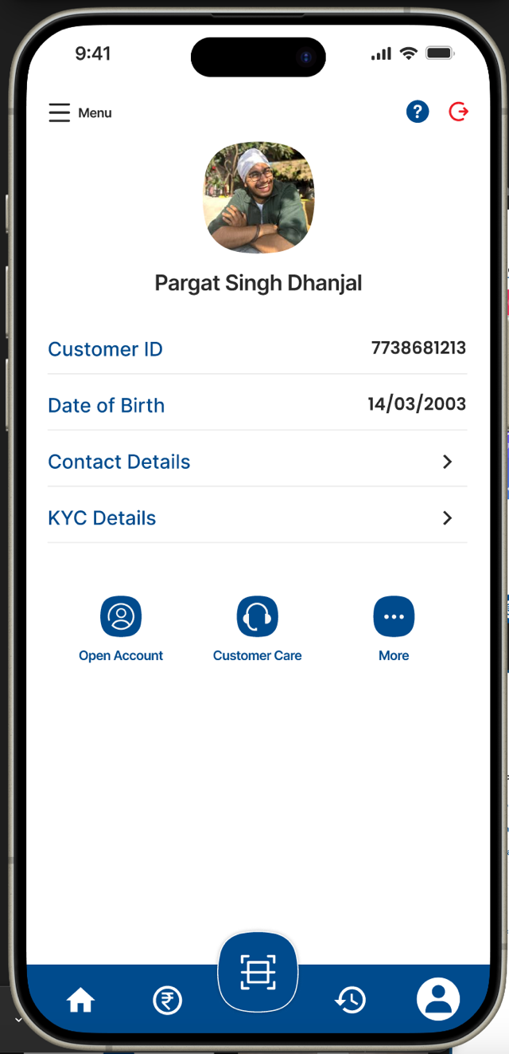 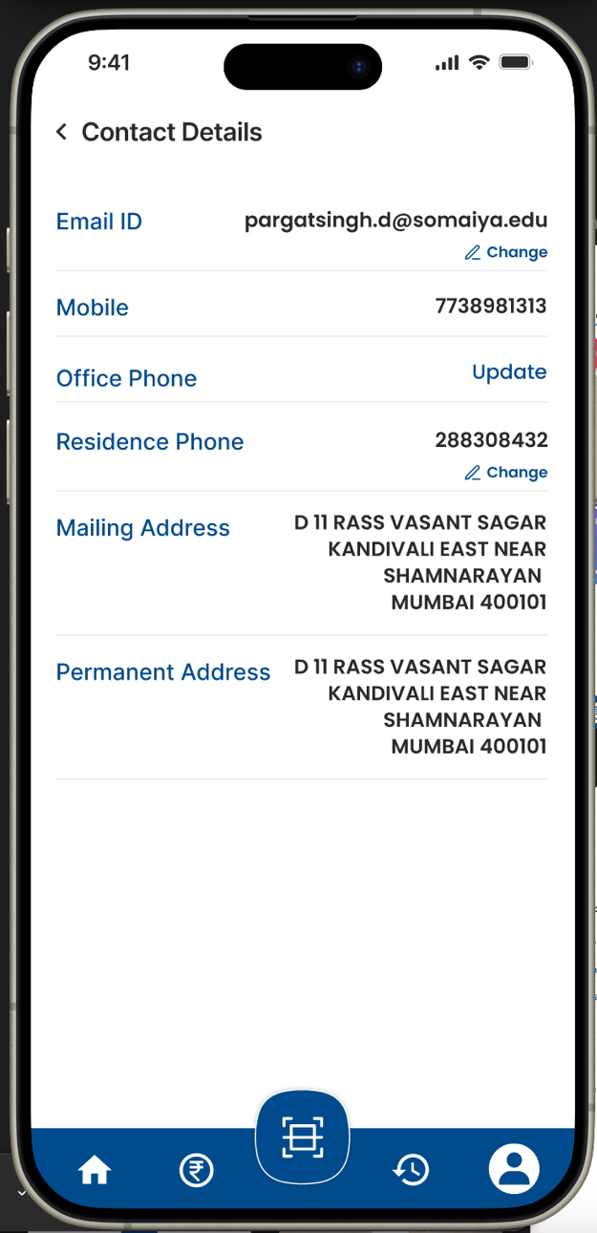

* **Profile & Contact Details Pages:** Group related information using proximity, allowing users to quickly identify contact details, KYC information, and other key attributes.

**Implementation in Current Application:**

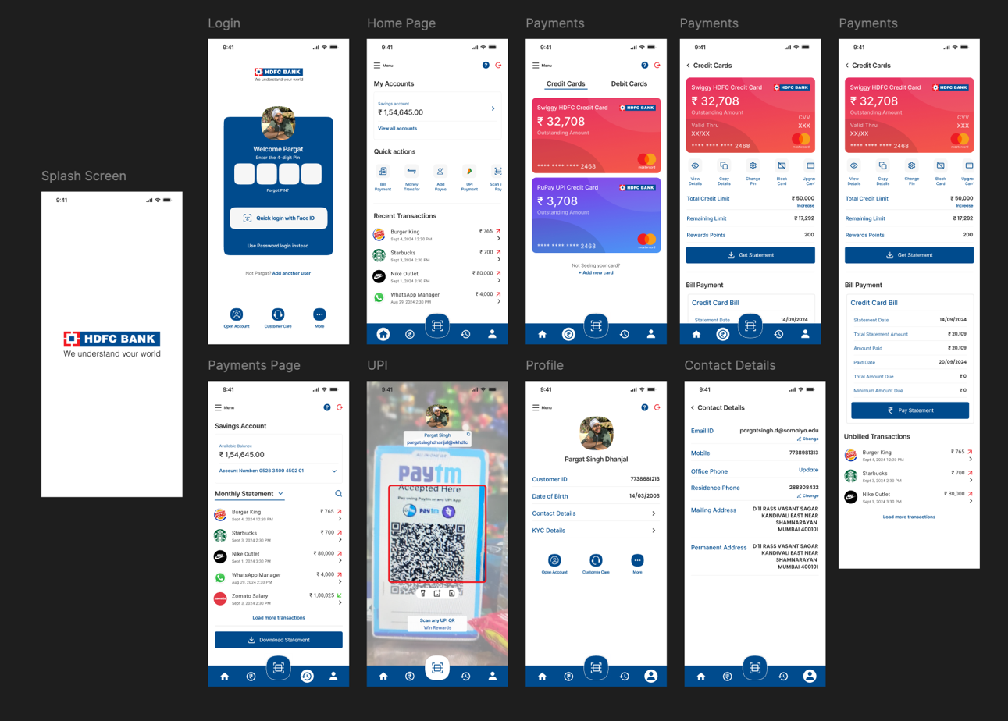

The findings from this experiment were applied to improve the HDFC Bank app by restructuring the home page, payments, and profile sections to ensure that all elements adhere to the principles of proximity and similarity. The updated design improves the user’s ability to scan information quickly and make decisions efficiently, thereby enhancing overall satisfaction with the application.

**Results:**

By integrating Gestalt principles into the interface, the app’s design was optimized for better user experience. Users found it easier to navigate through different sections, locate key information, and complete tasks such as viewing transactions or making payments. The experiment showed a significant reduction in time taken for users to perform key actions, thus validating the use of perceptual grouping in streamlining UI design for financial applications.

**Conclusion:**

The application of Gestalt principles to the HDFC Bank mobile app’s design has significantly improved its usability and overall user experience. By leveraging perceptual grouping through proximity, similarity, and continuity, the interface becomes more intuitive and easier to navigate. Users are able to quickly locate essential information, process actions more efficiently, and complete tasks such as payments and viewing account details with minimal cognitive load. This experiment demonstrates the value of incorporating psychological principles of visual perception into UI/UX design, particularly in complex applications like banking, where clarity and ease of use are critical. Future designs can continue to explore and refine these principles to further enhance user satisfaction and app performance.